Geometry Name: _______________________
10.1 & 10.2 Guided Notes

Review: 10-1 Circles and Circumference

A circle is the set of all points that are equidistant from the __________. A circle is named by its __________.

- Chord: Any segment with both _______________ on the circle.
- Diameter: A chord that passes through the ____________ of the circle.
- Radius: Any segment with endpoints that are on the ________ and a point ___________________.
Name a chord:
Name a diameter:
Name a radius:
B
F
A
D
E
C
Formulas for Circumference
C = or C =
Formula for Area:
A=

The circumference of a circle is the distance ______________ the circle.
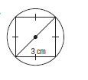
- Find the circumference of the following circle

Using the equations for circumference ( C ) in terms or the radius (r) and the diameter (d), answer the questions.

- $Find C if r = 4 cm$ | - $Find C if d = 10.5 in$ | - $Find d and r if C = 128.9 m$

Find the area of the circle in the following cases:

- $Radius = 3 cm$ 6. $Diameter = 7 cm$ 7. $Circumference = 40π$

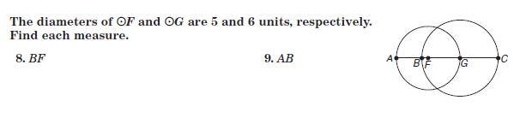

10-2 Measuring Angles and Arcs

A central angle has the __________ of a circle as its ____________, and its sides contain two __________ of the circle.

1
2
3
/1 , /2 and /3 are all central angles.
/1 + /2 + /3 = 360° since they form the whole circle.

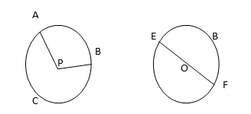
______ is a minor arc. A ___________ arc is an arc that measures less than ________
______ is a major arc. A __________ arc is an arc that measures more than _______.

_____ is a _________________, which has a measure of ______

- A central angle separated the circle into parts, each of which is an ______.
- The measure of each arc is related to the measure of its central angle.

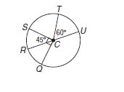
Find each measure:

- $m\hat{st}$

- m$\hat{su}$

- $m\hat{sq}$

- m$\hat{qt}$

Review: To find the length of an arc use the formula: $\frac{A}{360}=\frac{l}{2r}$

