GEOMETRY NAME___________________________
10.3 ARCS AND CHORDS NOTES DAY 1

The endpoints of a chord are also the endpoints of an arc. For any circle, two ___________arcs are ____________, if and only if their corresponding _____________ are ____________________.
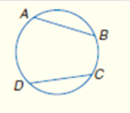
The chords of adjacent arcs can form a _______________. Quadrilateral ABCD is an ________________ polygon because all of its vertices lie on the circle.
Circle E is ______________________ about the polygon because it contains all the vertices of the polygon.

Let’s see some examples:

In a circle, if a diameter (or radius) is perpendicular to a chord, then it ____________ the chord and its arc.
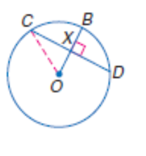
Example 1: Given the information below, find CX, OX, XB, and the $m\hat{CD}$.

CX =

OX =

XB =

$m\hat{CD}=$
(hint: think SOHCAHTOA)

In a circle or in congruent circles, two chords are congruent if and only if they are

__________________ ________ ________ ______________.

Example 2: Chords $\overline{AC}and \overline{DF}$ are equidistant from the center. If the radius of Circle G is 26, find AC and DE.

