Geometry Midterm Review 2016-2017 – Answer Key
10. statements | reasons
1. $\overline{RQ}$ $\overline{ST}$  2. RQ || ST  3. ∠RQU ≅ ∠TSU  4. ∠ QRU ≅ ∠ STU  5. Δ RUQ ≅ Δ TUS | 1. Given  2. Given  3. Alternate interior angles are equal.  4. Alternate interior angles are equal.  5. ASA

or

statements | reasons
1. $\overline{RQ}$ $\overline{ST}$  2. RQ || ST  3. ∠RQU ≅ ∠TSU  4. ∠ RUQ ≅ ∠ TUS  5. Δ RUQ ≅ Δ TUS | 1. Given  2. Given  3. Alternate interior angles are equal.  4. Vertical angles are equal.  5. AAS

- x = 9
- P = 38 units
- m∠ 1 = 70°, m∠ 2 = 110°, m∠ 3 = 46°,
m∠ 4 = 102°, m∠ 5 = 37°
- m ∠ 1 = 65°, m ∠ 2 = 25°
- P (-a, 0), Q (0, b), D (a, 0), A (0, 0), C (2v, 0)
- P = 140
examples: x = 5
H is a midpoint
EH = GH
ΔEFG = is scalene
- x = 30
- m ∠DEB = 145°, m ∠ BFE = 35°
- Δ ABC $≅$ Δ DEC, AB = DE, BC = EC,
AC = DC, ∠A = ∠D, ∠B = ∠E, ∠BCA = ECD
- see charts at right
- see charts at right
- Since DR ⊥ AG, ∠ DRA and ∠ DRG are both 90°.
DR is congruent to itself. RA ≅ RG is given.
Therefore D DRA ≅ D DRG by SAS.
- Youngstown and Cleveland
11. statements | reasons
1. ∠ V ≅ ∠ S  2. $\overline{TV}$ ≅ $\overline{QS}$  3. ∠1 ≅ ∠2  4. Δ TRV ≅ ΔQRS  5. $\overline{VR}$ ≅ $\overline{SR}$ | 1. Given  2. Given  3. Vertical angles are equal.  4. AAS  5. CPCTC

- 11.18 ft
- x = 27 mi
- x = $\sqrt{39}$
- slope = $\frac{1}{3}$, distance = $\sqrt{90}$ = 3$\sqrt{10}$, midpoint = $\left(\frac{3}{2}, \frac{7}{2}\right)$,
- slope = $\frac{2}{3}$, distance = $\sqrt{13}$, midpoint = $\left(\frac{1}{2}, 5\right)$
- x = 21, y and z = 93
- 118°
- x = 4
- a. parallel lines form congruent alternate exterior angles
b. parallel lines form supplementary consecutive interior angles
c. l and m are parallel
d. l and m are parallel
e. l and m are parallel
- m∠1 = 95°
- EF = 7
- $m ∠NLM=$40°$, m∠NLP=$50°$, m∠MLK=$140°$, m∠NLR=$220°$, m∠PLM=$90°
- false, false, true, false
- x = 11, x = 6
- XW = 15

- AL PL because a sides of a rhombs are equal. ∠NEA = 90 because diagonals of a rhombus are perpendicular. $\overline{EA}$ $\overline{EP}$ because diagonals of a rhombus bisect each other. NA || PL because rhombi are parallelograms. ∠NPE ∠EAL because parallel lines form alternate interior angles. ∠PLA ∠ANP because opposite angles are equal. ∠LNA ∠PLN because parallel lines form congruent alternate interior angles. ∠LEA = 90 because diagonals of a rhombus are perpendicular.

- (10, -6)
- Rhombus because all sides are equal, square because slopes are opposite reciprocals.
- translation
- rotation
- across x-axis (6, 1), across y-axis (-6, -1), across y = x (-1, 6), across y = -x (1, -6)
- Y(-7, 4)
- X´ (1, 7)

- G´(-1, 5)  N´ (-3, 7)  S´ (2, 8) | - B’ (0, 2)  U’ (-5, 2)  J’ (-1, 4)
- G´(0, -3)  R´ (4, -4))  L´ (-5, -1)  Z´ (-2, 1) | - C’ (1, 4)  K´ (5, 1)  B´ (4, 0)  L´ (0, -2)
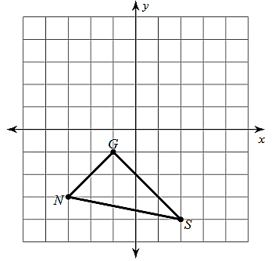
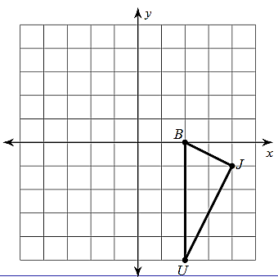

- false
- false
- false
- false
- false
- false
- false
- true

