**GEOMETRY NAME_______________________**

**Justification Extra Practice**

Vertical angles are __________ Consecutive interior angles are ___________________

Corresponding angles are __________ Linear pairs are ____________________

Alternate Interior angles are__________ Alternate Exterior angles are __________

Def of ⊥ Def of Complementary Def of Supplementary Def of < bisector

Def of right angle Angle addition Additive Inverse Substitution

Multiplicative Inverse CLT Straight Angle

**Using the word bank above, justify the setup of #1-12 below. Refer to the pictures shown below for each problem.**







1.<ABD=90° 2. <11=90° 3. <6≅<8

4. <8 +<5 =180° 5. <4 + <5= 180° 6. <3≅<7

7.<13≅<14 8. < 15+<16=90° 9. <ABD+<EFH=180°

10. <7≅<1 11. <12+<13+<14=<ABD 12. <6≅<4

|  |  |
| --- | --- |
| 13. Find x and y so that $\overset{⃡}{NR}⫠\overset{⃡}{MQ}$ | 14. Find y, ∠RPT and ∠TPW |

In the figure, $\vec{YX} and \vec{YZ}$ are opposite rays. $\vec{YU}$ bisects $<ZYW$, and $\vec{YT}$ bisects $<XYW$. Show your work. Justify steps!

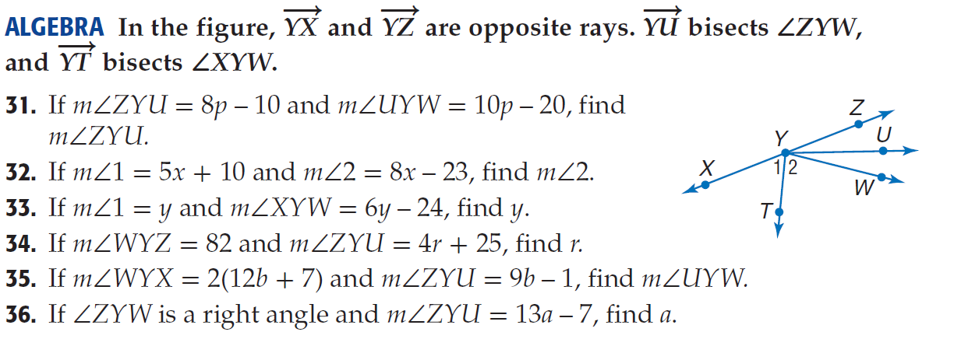

15. If and , find x

16. If the and the, find $x$