GEOMETRY NAME________________________________
LINE SEGMENT AND ANGLE NOTES & PRACTICE

Directions: Illustrate the following.
1. $\overline{AB}≅\overline{XY}$ 2. $<XYZ≅<ABC$

3. Point P is the midpoint of $\overline{MN}$ 4. Line m is a segment bisector of $\overline{AB}$

5. $\vec{RS}$ is an angle bisector of $<TRV$ 6. Line l is a ⊥ bisector of $\overline{HI}$

7. $<1$ and $<2$ are linear pairs 8. $\vec{AB}$ and $\vec{AC}$ are opposite rays

9. <LMN is a right angle 10. <2 is an obtuse angle

GEOMETRY NAME________________________________
LINE SEGMENT AND ANGLE NOTES & PRACTICE

Directions: Illustrate the following.

1. X is the midpoint of $\overline{AB}$ 2. $\overset{⃡}{AB}$ is a ⊥ bisector of $\overline{GH}$

3. <ABC and <CBD are linear pairs 4. Line d is an angle bisector
of < LMN

5. $<WXY≅<JKM$ 6. $\overline{PM}≅\overline{ED}$

Directions: Refer to the figure.

7. Name a line that contains point P.

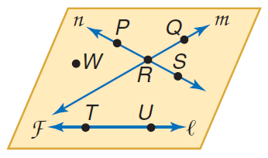
8. Name the plane containing lines n and m.

9. Name the intersection of lines n and m.

10. Name a point not contained in line l, m, or n.

11. What is another name for line n?

12. Does line l intersect line m or line n? Explain.

