**Geometry Name: ______________________________**

**Midterm Practice Day 1**

Fill in the blanks to the following statements.

1. _________________ is a quadrilateral with one pair of opposite sides parallel.

2. _________________ is a quadrilateral with 4 right angles.

3. _________________ is a quadrilateral with 4 congruent sides.

4. _________________ is a quadrilateral with opposite sides parallel.

5. _________________ is a quadrilateral with 2 pairs of consecutive congruent sides.

6. _________________ is a quadrilateral with one pair of opposite sides parallel and non parallel sides (legs) congruent.

7. _________________ is a quadrilateral with 4 right angles and congruent sides.

8. Partridge Creek, Buffalo Wild Wings, and Dakota High School form a triangle on a map. What route would have the shortest drive? (i.e. Which two buildings are closest together?) Show me mathematically

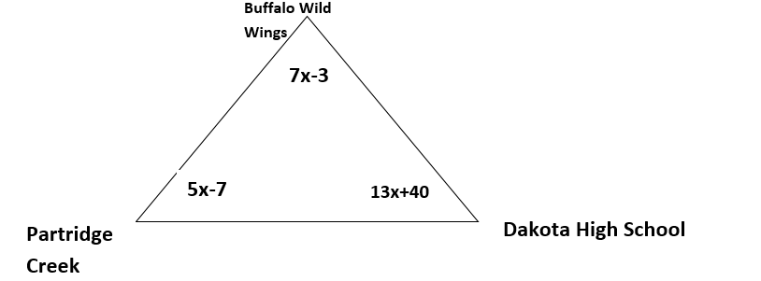

X= _____ <BW3 = ___________ <DHS= ______________ <PC= ____________

9. If all sides of a quadrilateral are 17m, classify all that apply.

**I. Parallelogram**

**II. Rhombus**

**III. Rectangle**

**IV. Square**

|  |  |  |  |
| --- | --- | --- | --- |
| a. | I only | e. | I & II |
| b. | II only | f. | II & IV |
| c. | III only | g. | I, II & IV |
| d. | IV only | h. | ALL four |

10. If all angles of a quadrilateral are 90 degrees and all sides are 17m, classify all that apply.

**I. Parallelogram**

**II. Rhombus**

**III. Rectangle**

**IV. Square**

|  |  |  |  |
| --- | --- | --- | --- |
| a. | I only | e. | I & II |
| b. | II only | f. | II & IV |
| c. | III only | g. | I, II & IV |
| d. | IV only | h. | ALL four |



11. What is the value of $2a+8p-7x$?

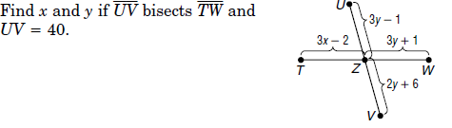12.