In Class Practice – Day 3
H. Solving Systems of Equations

Two equations, such as y = 3x + 2 and y = -6x + 12, together are called a system of equations.

A solution of a system is an ordered pair that satisfies both equations. A system of two linear equations can have one solution, infinitely many solutions or no solutions.

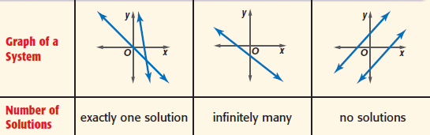

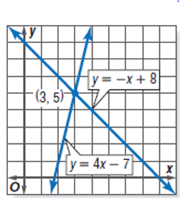
Example A: Solve by graphing
Graph both lines. The point where the lines intersect is the solution.

y = -x + 8 and y = 4x – 7

The solution is (3, 5).

If the lines are parallel, there is no solution to the system.
If the lines are the same, there are infinitely many solutions to the system.

Example B: Solve by substitution
x + 3y = -6 and 0.5y – x = – 4.5

Step 1: Isolate a variable in one of the equations. (Consider which one would be easier.)

Step 2: Substitute Step 3: Solve for the remaining variable.

Step 4: Solve for the other variable. Substitute the value into one of the original equations.

Step 5: Write your answer as an ordered pair.
Example C: Solve by elimination (addition/subtraction)

2x – 4y = -26 and 3x – y = -24

Step 1: Align the variables

Step 2: Multiply one of the equations so that the coefficients of one of the variables are equal.

Step 3: Add or subtract the equations in order to eliminate one of the variables. Solve for the
remaining variable.

Step 4: Solve for the other variable. Substitute the value into one of the original equations.

Step 5: Write your answer as an ordered pair.

I. Operations with Fractions

When adding and subtracting fractions, you must ALWAYS have common denominators.
What do you do if the denominator is NOT the same?

$\frac{4}{7}+\frac{2}{3}$ =

Multiplying and Dividing Fractions:
To multiply or divide you do NOT need common denominators.
- Multiplication: Multiply the numerators, multiply the denominators and simplify your answer.
- Division: Flip the second fraction and multiply.

Example: Multiplication Example: Division
$\frac{4}{7}●\frac{3}{8}=$ $\frac{4}{7}÷\frac{3}{8}=$

J. Quadratics
A quadratic equation is an equation with a degree (highest exponent) of 2. You can solve quadratic equations by factoring, graphing, completing the square, or using the quadratic formula.
quadratic formula: x = $\frac{-b ±\sqrt{b^{2}- 4ac} }{2a}$$\frac{-b ± \sqrt{\begin{aligned} \\ \begin{aligned} \\ \\ \begin{aligned} \\ b^{2}- 4ac\end{aligned}\end{aligned}\end{aligned}}}{2a}$

When 0 = ax² + bx + c

Example A: solve with quadratic formula

Solve 24x² – 14x = 6

Step 1: Rewrite the equation in standard form.
Step 2: Use the values of a, b and c in the quadratic formula.
Step 3: Simplify to find solutions.

Examples B and C: solve by factoring

Solve x² – 9x + 20 = 0 | Solve 2x² – 7x = 0

*Practice: Solving by Graphing
Solve each system of equations by graphing.
- y = 2x – 3  y = $\frac{1}{2}$x | - y = – $\frac{1}{2}$x + 2  y = –3x–3 | - y = $-\frac{1}{3}$x – 1  2x + y = 4
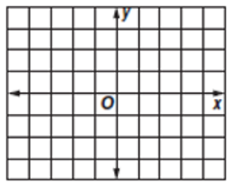

*Practice: Solving by Substitution

Solve by substitution.
- y = -3x + 7  4x + 2y = 16 | - 2x + y = 5  1.5x – 1.5y = 1.5 | - 2x + 3y = -3  x = -2y + 2

*Practice: Solving by Elimination

Solve by elimination.
- 2x – y = 7  3x + y = 8 | - 3x + 4y = -10  2x – 8y = 4 | - 5x – 2y = -15  3x + 3y = 12

*Practice adding/subtracting fractions

- $\frac{2}{5}+\frac{1}{5}=$ | - $\frac{2}{5}-\frac{3}{4}=$
- $\frac{4}{9}-\frac{7}{9}=$ | - $\frac{8}{9}+\frac{1}{3}=$

*Practice multiplying/dividing fractions
- $\frac{8}{9}●\frac{3}{4}$ = | - $\frac{8}{9}÷\frac{3}{4}$ =
- $\frac{1}{9}●\frac{1}{18}$ = | - $\frac{1}{9}÷\frac{1}{18}$ =
- $\frac{2}{7}●\frac{4}{7}$ = | - $\frac{2}{7}÷\frac{4}{7}$ =
*Practice: Solving Quadratics using Quadratic Formula

1. x² + 10x + 12 | 2. 3x² + 7x - 20

*Practice: Solving by Factoring

- x² + 11x + 24 = 0 | - x² – 3x + 2 = 0
- x² + 13x – 48 = 0 | - x² – 2x – 35 = 0
- x² + 20x = 0 | - 3x² + 27x = 0

