GEOMETRY NAME: ________________________
REAL WORLD PRACTICE B
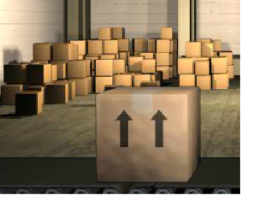
1. How many more inches of cardboard does a cube-shaped box with a side length of 8 inches have than a cube shaped box with a side length of 4 inches?

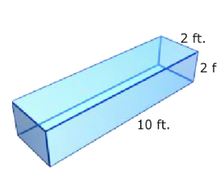
2. The outside of the pharaoh’s casket will be painted. The dimensions of the casket are shown in the diagram. Calculate the surface area of the 6 sides so that the proper amount of paint can be mixed.

3. Find the surface area of the composite.

Find the surface area for the solids. Round to the nearest tenth, if needed.

4.

5.

