GEOMETRY NAME: ___________________________
LATERAL/SURFACE AREA/ VOLUME REVIEW

PRISMS

Find the lateral area of each prism. Round to the nearest tenth if necessary.
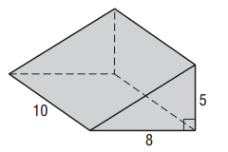 | 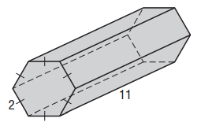 | 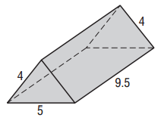
Find the surface area and volume of each prism. Round to the tenth if necessary.
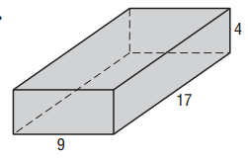 | 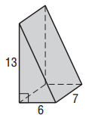 | 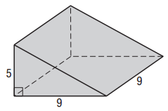

CYLINDERS
Find the surface area and volume of a cylinder with the given dimensions. Round to the nearest tenth.
- r = 10 in., h = 12 in. | - r = 5 ft., h = 20 ft. |  | - d = 8 m, h = 7m
Find the surface area and volume of the cylinder. Round to the nearest tenth.
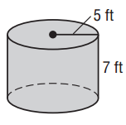

Find the radius of the base of each cylinder.
- T = 603.2 m², h = 10 m |  | - T = 226.2 cm², h = 5 cm

PYRAMIDS
Find the surface area and volume of each regular pyramid. Round to the nearest tenth if necessary.
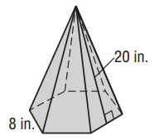 | 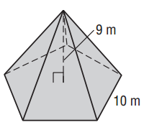
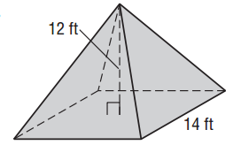 | 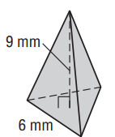
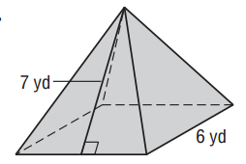 | 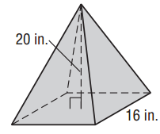

CONES
Find the surface area and volume of each cone. Round to the nearest tenth if necessary.
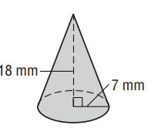 | 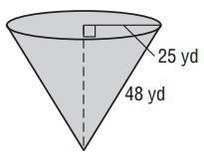 | 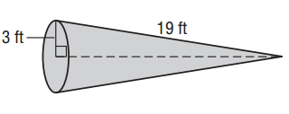
- Find the surface area of a cone if the height is 8 feet and the slant height is 10 feet.

- Find the surface area of a cone if the height is 12 inches and the diameter is 27 inches.

- You purchased a conical hat when shopping at Party City. The basic frame of the hat is 16 hoops that gradually diminish in size and covered in paper. If the hat has a diameter of 50 cm. and a slant height of 32 cm., what is the lateral area of the conical hat?

SPHERES/HEMISPHERES
Find the surface area and volume of each sphere or hemisphere. Round answers to the nearest tenth if necessary.
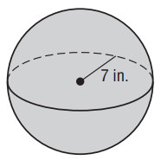 | 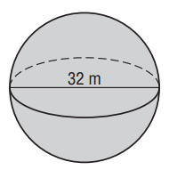
Find the surface area and volume of each sphere or hemisphere. Round answers to the nearest tenth if necessary.

- a hemisphere with a radius of the great circle of 8 yards.

- a hemisphere with a radius of the great circle of 2.5 mm.

- a sphere with the area of the great circle of 28.6 in.

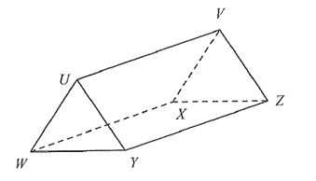
Identify the following solids.

- A. rectangular prism
B. rectangular pyramid
C. triangular prism
D. triangular pyramid

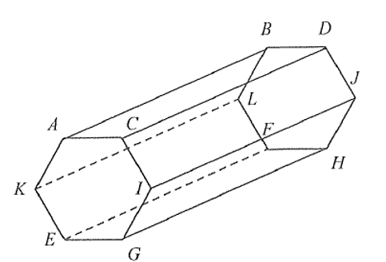
- A. cylinder
B. hexagonal Prism
C. pentagonal Prism
D. hexagonal Pyramid

- Baseballs and softballs come in different sizes for different types of leagues. If the diameter of a baseball is 3 inches and a softball has a diameter of 3.8 inches, find the difference between the volumes of the two balls. Rounds to the nearest tenth.

- Find the volume of a rectangular prism that is 10 cm long, 14 cm wide, and 19 cm high. What is the effect on the volume of the rectangular prism when each dimension is doubled.

- Find the surface area and volume of the following composite.
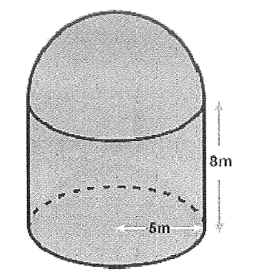
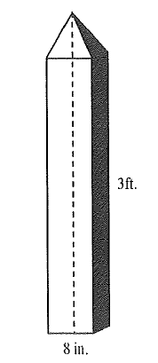
- Brandon made a model of a tower as shown below. It is composed of a square prism and a square pyramid. The height of the pyramid is 2 inches. He would like to paint the model tower and knows one can of paint covers 900-1000 square inches. How many cans of paint does Brandon need to give the model tower one coat of paint?

- A hot water heater is in the shape of a cylinder. Find the amount of insulation need to cover just the sides of the hot water heater.
